Creating a Favicon

Here’s what you need to know about creating a favicon for your web page.

The image needs to be an ‘.ico’ file. And you need to reference it in the head of you html page.

<link href="favicon.ico" rel="icon"/>   
<link href="favicon.ico" rel="shortcut icon"/>

Some browsers don’t need this reference as long as the image is called ‘favicon’ and located in the root folder of your website. But it is always better to be safe than sorry, so include the lines with the path to your ico file.

To create an .ico file it’s not as easy as changing the extension of your png to ico. Ico is a completely different image format. Previously I useds an online image convertor that returned me an ico file when I uploaded a png file. Don’t use this, it is not what a browser wants.   
An ico file contains multiple images in different sizes all within one file. The browser then chooses the right icon to use in the right place. The standard sizes are:

* 256×256
* 48×48
* 32×32
* 24×24
* 16×16

They are all used in different places throughout the web experience.

To create icon from an image follow these steps:

1. Make sure you have a png or jpg image you want to use.
2. Download and install the free program IcoFX (<http://icofx.ro/>).
3. Start IcoFX.

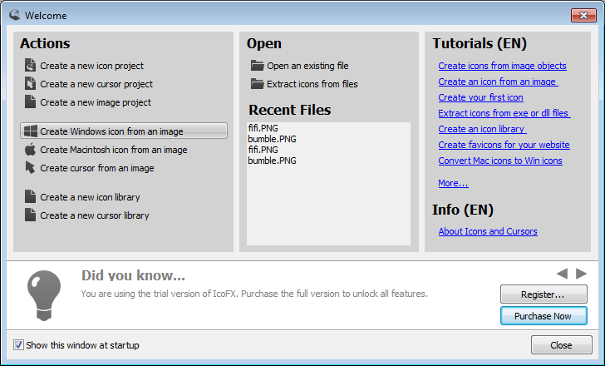

1. Choose Create Windows icon from an image.
2. Open the image that you would like to convert to icon. You can use PNG, BMP, GIF, TIF, IFX, JPG or JP2 images.
3. From here you can select part of the image you want as the icon (select the part you want, copy it and paste as a new image) or leave the image in its entirety.
4. Your image contains only one image format. Use the "Create Windows Icon From Image..." menu item to add all the needed image formats to the icon.



1. Make sure the following are selected. Click OK.

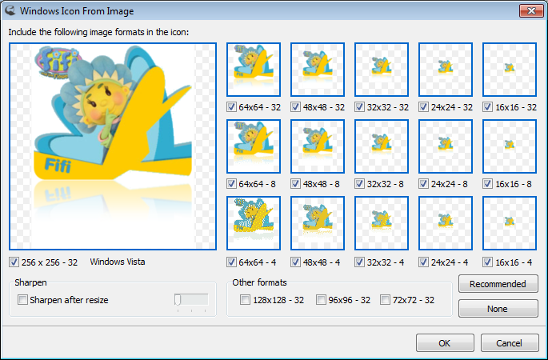

1. Save the icon using the "File/Save As..." menu item. On the save dialog choose the desired output format in the "Save as type" combo box (.ico) and enter the name favicon. Your icon is ready.
2. Include the 2 lines of code from the beginning of this file in your html file. You will have to test this through a web server.